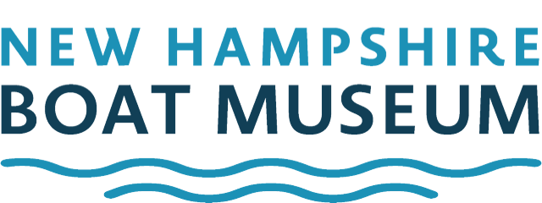
130 Whittier Highway, Moultonborough, NH 03254
Phone (603) 569-4554 / www.nhbm.org
BOAT AUCTION DONATION CONTRACT AGREEMENT
(Please read Terms & Conditions prior to completing form)

Name _ Address City State ZIP Tel: ( ) E-mail Copy of a Pictured ID: Yes / No State Issued Date Issued Donor’s Tax Payers ID #
DONATION DESCRIPTION
Please describe your boat / engine or item as accurately as possible as this information will be used in advertising and at the auction block for description purposes. We do require a Statement of Condition for all engines. You are responsible for the representation of this information.

NOTE: Most recent boat / trailer registrations must accompany donation form. Items without the proper paperwork cannot be included in the auction. All donors must ensure that both their boat and trailer are properly tagged with their name using indelible ink.

BOAT INFORMATION: Year Make_ Model Length_

Hull #_ # of Engines Make # of Cylinders HP

TRAILER INFORMATION: Make Model # of Axles VIN / Serial #

ITEM/S INFORMATION:

continue on back Repair, Reconditioning or Restoration History
continue on back

I (we) own the personal property described above and desire to donate said property to the New Hampshire Boat Museum. I (we) do hereby irrevocably and unconditionally (subject to an attached agreement) give and transfer to the New Hampshire Boat Museum all right, title and interest, including all copyright, trademark and related interests, in and to the property described. Further, I (we) as donor warrant that the property being transferred to the museum is free and clear of any liens and encumbrances.

By my signature below, I accept the foregoing conditions and acknowledge reading any attached agreement.

Dated: Donor

Date Received For the NH Boat Museum

Please read, sign, and return original signed copy of the Statement of Condition along with the Donation Agreement.
Revised 3/18/2026

Statement of Condition
Please fill out, sign and attach to donation form.

I (the donor)

Address:

Town:

State & ZIP:

Certify that I have owned the following:

BOAT INFORMATION: Year Make Model Length Hull #_ # of Engines Make # of Cylinders HP_ TRAILER INFORMATION: Make Model # of Axles

VIN / Serial #
Describe the Engine Operation: (Please include when last ran.)

continue on back Provide owner’s manuals and describe repair record: (Supply copies of any and all material if available)

continue on back

The above property is being sold in “as is condition”. The donor makes no warrantees, express or implied (except as specifically stated above.)

Donor Signature: Date:

Please complete, sign, and return original with the Donation Agreement.
Revised 3/18/2026

