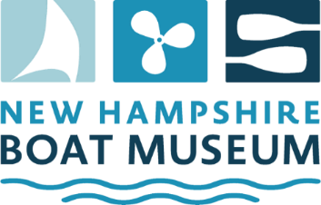

Position Title: Community Sailing Program Volunteer – Program Monitor
Reports to: Community Sailing Committee Chair
Status: Part-time Volunteers, July-Aug, approximately 4 hours per Monday during the sailing season
Location: Wolfeboro, Lake Wentworth - Albee Beach
To apply: Contact Anne Lennon: programs@nhbm.org or 603-

Position Summary
Offered in partnership with the Wolfeboro Parks & Recreation Department (WPRD), observe the beginning of Community Sailing Program classes on Mondays (8:30am – 10am, and 12 noon – 1:30pm) during July until mid-August. Volunteer for one Monday or multiple.

Responsibilitie sinclude:
- Greet students and their guardians / relatives at the first classes of each week (Mondays) during the season.
- Representing NHBM, promote the museum and its activities to students and their guardians / relatives.
- Observe swim tests and help instructors with parent conversations regarding water safety or other issues that may arise.
- Observe the start of classes, monitoring safety and effectiveness.
- Note needed repairs to boats as reported by the instructors and inform sailing committee chair or designee.

Qualifications
Strong interpersonal and oral communication skills. Knowledge of NHBM activities and general knowledge of current museum exhibits.

