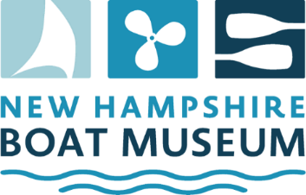

Position Title: Community Sailing Program Volunteer – Program Monitor
Reports to: Community Sailing Committee Chair
Status: Part-time Volunteer, July-Aug, approximately 5 hours per week during the 5-6 week sailing season
Location: Wolfeboro, Lake Wentworth - Albee Beach
To apply: Contact Kerry Lynch: Lynchkg357@gmail.com

Position Summary
Offered in partnership with the Wolfeboro Parks & Recreation Department (WPRD), monitor the Community Sailing Program classes in July and August, and assist the sailing instructors as necessary. Representing NHBM, promote the museum and its activities to students and their guardians / relatives.
With support from volunteer members of the Sailing Committee:
- Orient small boat sailing instructors with a focus on care and safe use of NHBM’s equipment.
- Greet students and their guardians / relatives at the first classes of each week during the season.
- Observe small boat classes periodically, monitoring safety and effectiveness.
- When present, assist instructors as needed.
- Oversee needed repairs to the fleet during the 5-6 weeks of classes each season.

Qualifications
Strong interpersonal and oral communication skills. General boating and repair knowledge. Willing to be flexible during the 5-6 week summer sailing season. The position requires some physical endurance including ability to lift/carry up to 50 lbs.

